40.25: a) Probability of tunneling is 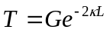
where 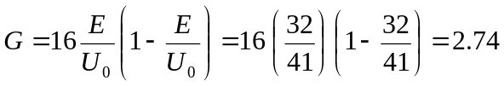
and 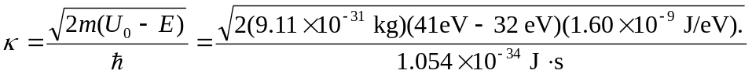
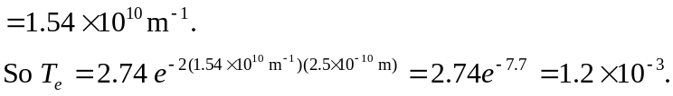
b) For a proton, 